Tracker and Feature Function Integration into DC

Tracker repository: CORECOMP/ALSW/OT_ObjectTracking
Feature Function repository: CORECOMP/ALSW/SFL_SideFeatureLogic

Tracker Integration
Whenever a new Tracker needs to be integrated into DC, check emails from the Tracker team and take the required ROT and RSPP versions. The mail title is something like this “F360/ROT v10.37.00 - SW release candidate is available.”
Commit id would be mentioned in the mail , just pull to that commit
- In DC, the selected folders are to be updated from Tracker repository
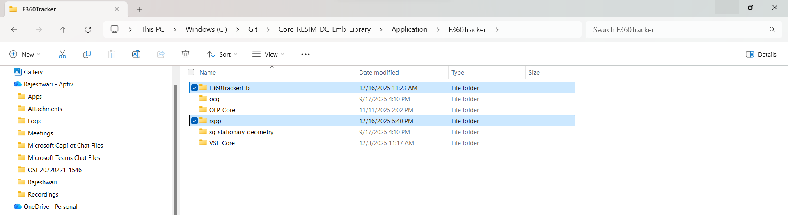
- In Object Tracking repository, below selected is the location of F360TrackerLib and rspp.
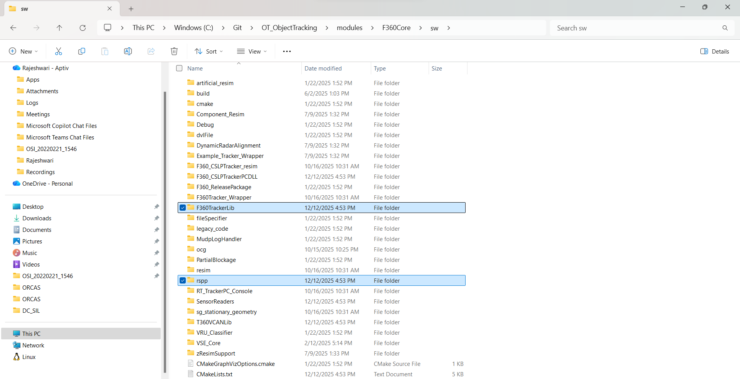
NOTE: Each time when tracker is updated in DC, make sure both rspp and F360TrackerLib folders are updated.
- Don’t just copy-paste the folder from Tracker repo to DC as it will overwrite changed files and add new ones, but it will not remove files that were deleted in the Tracker repo. Those old files will remain in DC repo, which can cause build/runtime issues.

- Instead, compare the existing folder from DC and latest folder from Tracker using Beyond Compare and replace manually.
While updating the Tracker files, retain the below changes made previously, as these modifications are required and should not be overwritten.

- In F360TrackerLib\SharedTrackerAPI\core\variants\f360_variant_definition_a.h the variable NUMBER_OF_REDUCED_OBJECT_TRACKS is always 250.

- Make sure F360TrackerLib\SharedTrackerAPI\core\f360_variant_definition.h is also updated properly.

- In F360TrackerLib\SharedTrackerAPI\Logging\f360_rot_object_log.h, comment out the line LOGSIZE_ASSERT(ROT_Object_List_Info_T, 142116U); as that throws some error

FF Integration
In DC, below folder is to be updated for Feature Functions
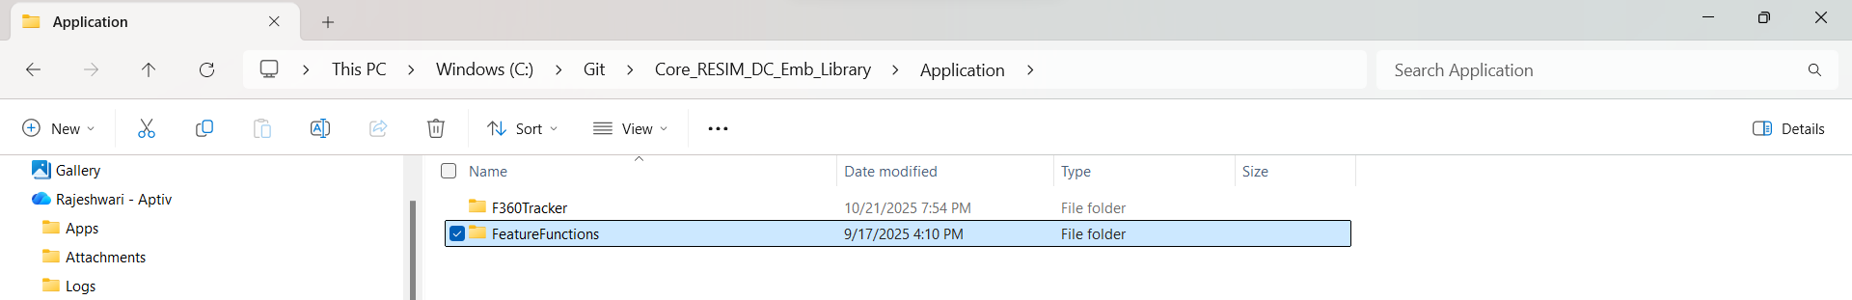
Calibration_Tool and Math_Library are submodules to SFL Repo. So, clone those repos as well
Calibration_Tool Repo: CORECOMP/ALSW/CT_CalibrationTool
Math_Library: CORECOMP/ALSW/ML_MathLibrary
Math_Library has dependency on ST_SharedTools
ST_SharedTools: CORECOMP/ALSW/ST_SharedTools
Make sure to clone above repos to the commit mentioned in SFL repo document.
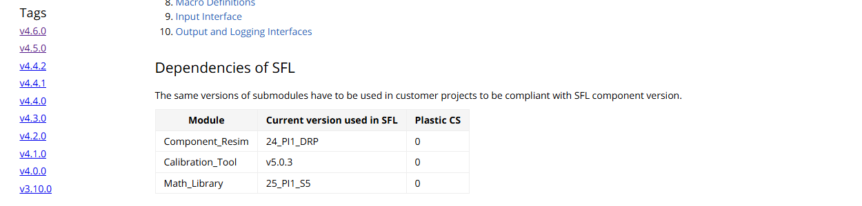

Changes to be retained:
- Under FBK, In CMakeLists.txt
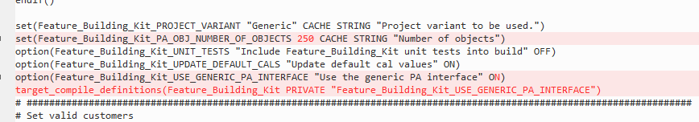
1. Feature_Building_Kit_PA_NUMBER_OF_OBJECTS should be made as 250.
2.Feature_Building_Kit_USE_GENERIC_PA_INTERFACE should be ON
3.Add the below lines in CMake
target_compile_definitions(Feature_Building_Kit PRIVATE "Feature_Building_Kit_USE_GENERIC_PA_INTERFACE")
target_link_libraries(Feature_Building_Kit AS-bin-writer-lib)
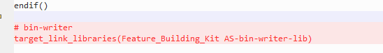

- In Feature_Building_Kit\Platform_Abstraction_Layer\All_Valid_PA_Options.cmake,
add the below line
set(PA_Generic "Generic")

